For storing real number we will use

a..float

B.double

Float:

Float.SIZE

Flaot.MIN_VALUE

Float.MAX_VALUE

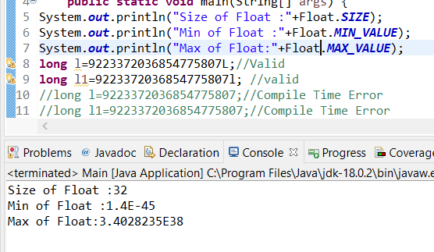

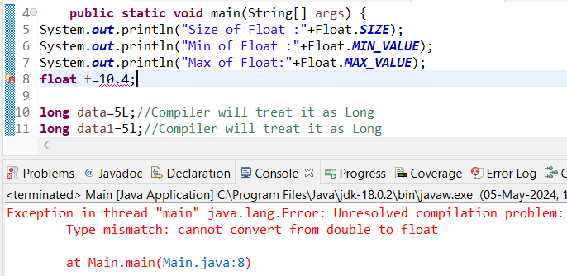

Compiler by default will treat every real number as double.



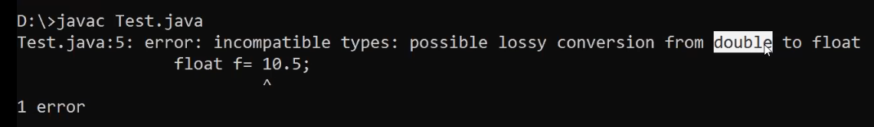

Compiler by default treats the above real number as double due to which it is throwing Compile time Error.

In order to specify to the compiler to treat it as float we need to add the suffix ‘F’/’f’ at the end.



Double:

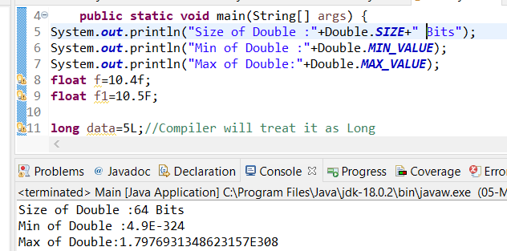

Note : Data types are actually represented to the compiler and jvm using reserved words.

 Reserve words are normally lower case.

To map primitive type data as objects in java from jdk 1.5 concept of “Wrapper classes” are introduced.

byte —--Byte(C)

int —------Int

float —-Float

short—-------Short

double—-----Double

long—--------Long

Char :

All the characters/numbers/Every thing has to stored in the form of 0/1’s

ASCII : American standard code for information interchange.

For each of the Character there will be an ASCII value associated with it.

As per ASCII there were 128 characters. For storing each character we would require 7 bits

As memory comes in Byte format.

As per UNICODE/UTF we have 65536 characters.

16 bits—2 Bytes

So to store these 65536 characters we use 16 bits.

Java uses 2 Bytes to store Character data.

Java follows UNICODE format.----Uses 16 bits to store a character.

syntax=

char  a=’A’

For char the Wrapper class is Character

In java Array & String are treated as Object type.

Java is not a completely object Oriented programming language because of the primitive data types it has.

When we perform operations on int the result will always be an integer.

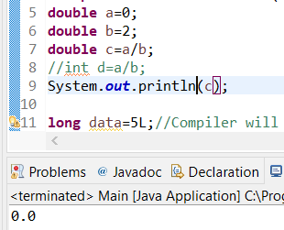

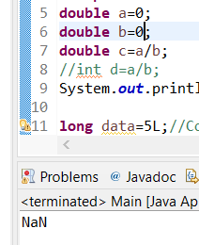

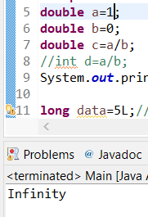

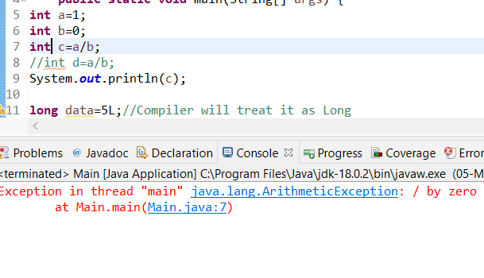

From the above we could see that the data of a1(byte) is getting converted to double(d1) and stored in d1.

The type conversion is happening implicitly .We call that as implicit type casting/Numeric integer Promotion.

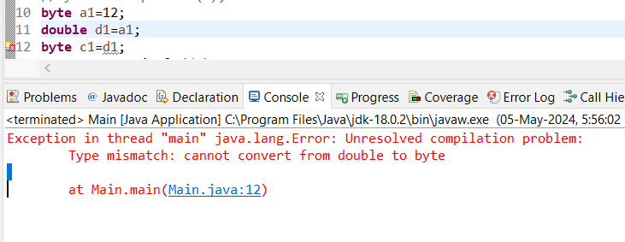

Byte→short→int→long→float→double   All  these castings will be valid and they will called implicit type casting

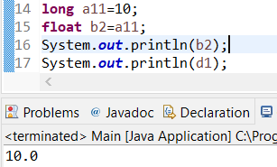

long data type value we were able to store in float after casting.

Explicit Type Casting :

Converting to other data type explicitly we will call that Explicit type casting.

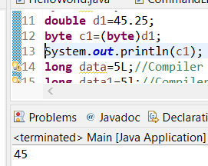

As we could see from the above that the double data type has been explicitly converted to byte.

For explicit type casting there might be loss of data.

When we perform any operation by default the result will be converted to int.So we can store the result in int/typecast it to required format.

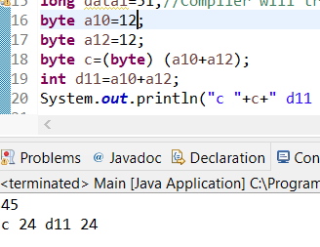

From the above see we could see that we have type casted to byte or stored the result in int.

javac–Java Compiler

Operators

A++ —>post incremen

++A→pre increment

A– →Post Decrement

–A →Pre Decrement

**int** a=5;

a++;

System.***out***.println(a); /////6

**int** a=5;

++a;

System.***out***.println(a);///6

**int** a=5,b=0;

b=++a;

System.***out***.println("a="+a+" b="+b);//a=6 b=6

**int** a=5,b=0;

b=a++;

System.***out***.println("a="+a+" b="+b);//a=6 b=5

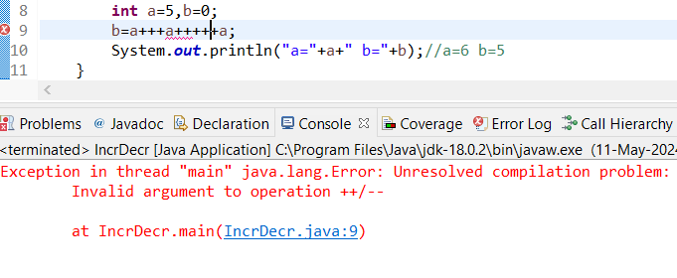

int a=5,b=0;

b=a++ +a++ + ++a;

System.out.println("a="+a+" b="+b);//a=8 b=19

We will move from left to right

Initial value of a =5 which will be used for during addition and assigning to b.

b=5

Later it will be incremented to a=6

Step 2:

a=6

b=5+6

The value of a will get incremented by 1

a=7

Step 3 :

a=7

++a will make value of 8 and that will be used for addition in Expression

b=5+6+8

So final Values a=8 b=19

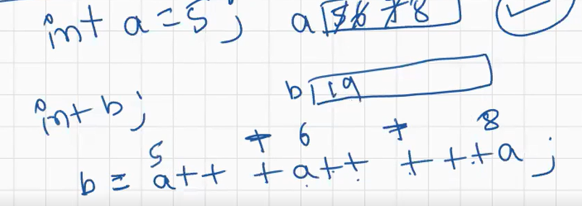

**int** a=5,b=0;

b=++a + a++ + ++a +a--; //6+6+8+8

System.***out***.println("a="+a+" b="+b);//a=7 b=28

**int** a=5,b=0;

b=a++ + --a - a-- - a++;//5+5-5-4

System.***out***.println("a="+a+" b="+b);//a=5 b=1

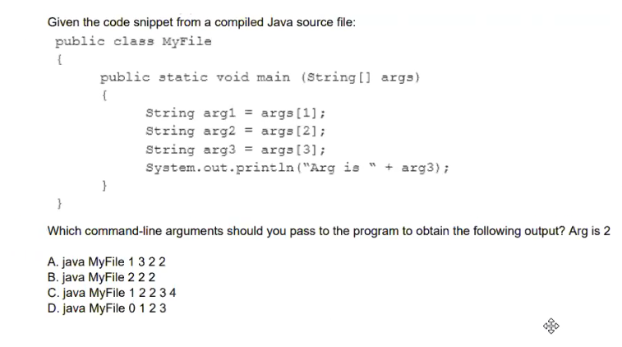

A

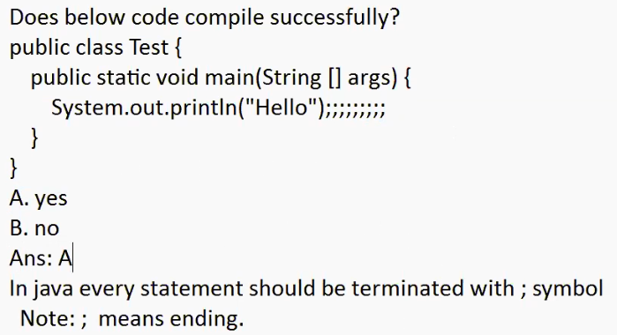

A

Statement can have any number of semi colons

Compiler will ignore these and take only one colon while generating .class file to JVM.

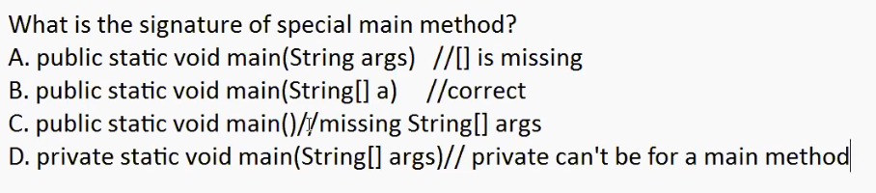

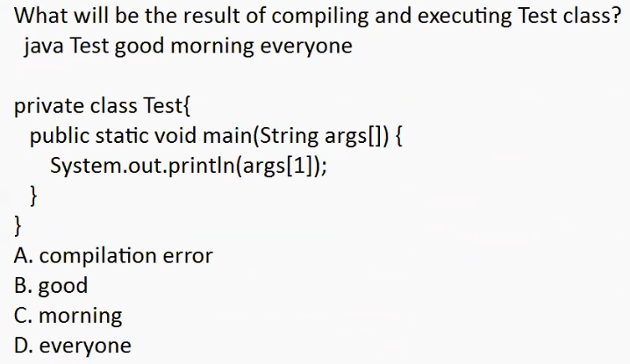

The class name of main method has to be Public

1. Compilation Error

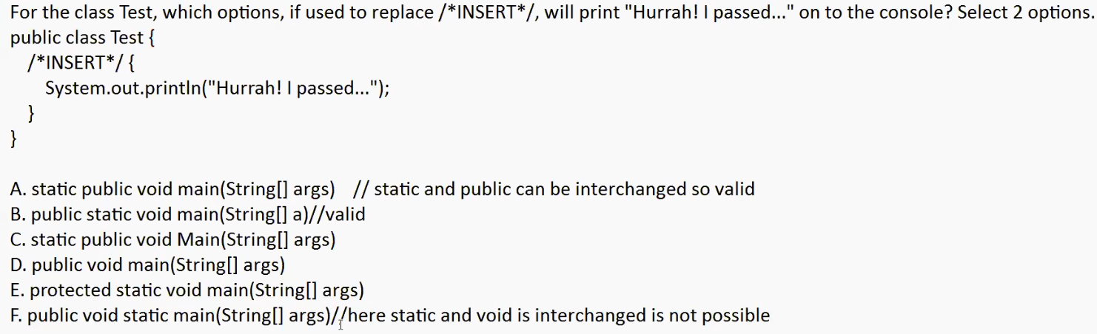

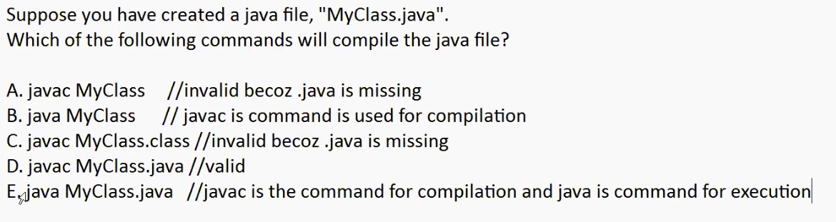

D

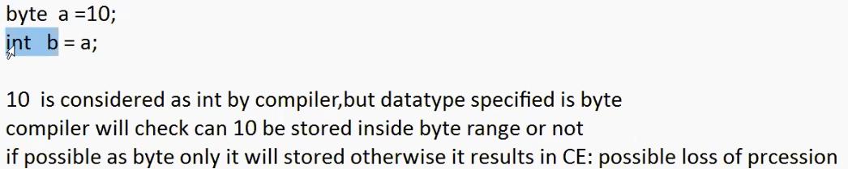

Every long value can be stored in float because of the internal arrangement.



java MyClass.java is valid from JDK11version—Both the compilation and execution will happen.

Collection of .class files we represent as Jar Files.

Main method : It is method from which JVM will start execution.

Private class Demo

{

Public static void main(String args[])

{

System.out.println(“Sai”)

}

}

---Class Which contains main () method should be declared as public.